**Final Exam Study Guide-7th Grade** Name_________________________

You may need to make notes on another sheet of paper to study for the test. In addition, you need to review all tests, notes, and quizzes.

**Nature of Science (NOS)**

1. Steps of the Scientific Method:
2. Why do scientists repeat experiments done by other scientists?
3. What is the difference between a theory and a law? Can they both change? Explain

What is the difference between a theory and a hypothesis?

1. Give an example of how newly discovered information can change existing knowledge.
2. Why do we often use models in science? What are some limitations of models?
3. Are there different kinds of scientific investigations? Do they all involve an experiment? Explain
4. Fredrick thinks that coffee will make his plants grow taller. Explain a way that he could test his hypothesis.

**Energy-Chapters 8, 9, 10**

1. Look at the diagram on pg. 304 and read the section above it. What types of energy come from the sun?
2. What type of energy is found in the electromagnetic spectrum? (chap. 8)
3. Which part of the spectrum can we see?

1. List the colors in the visible spectrum in order from the longest to shortest wavelength. What can we use to remember the order of the colors?
2. What property of waves makes the types of waves in the spectrum different?
3. List and describe types of wave interactions. (chap. 9).
4. What does the Law of Reflection state? (hint-see pic below)

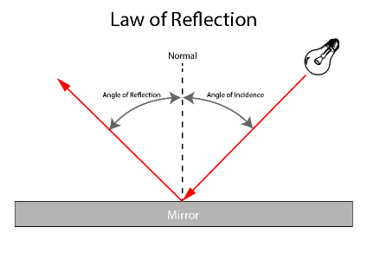

1. What would the angle of reflection be for the following reflected wave?

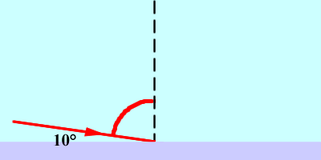

1. Which type of wave interaction explains why objects look different under water? Why does this occur?
2. Waves carry _______________, not matter.
3. How does heat affect molecular motion?
4. Describe how heat and phase change of matter are related.
5. What is the difference between heat and temperature?
6. Describe the direction in which heat transfers from one object to another.
7. Describe photosynthesis (plants making their own food-sugar) as it relates to energy transfer.(see diagram pg. 568)
8. List the types/forms of energy.
9. How do most power plants generate electricity?
10. What does a prism do to light?
11. Describe the relationship between speed of waves and the type of medium (material) they pass through.
12. Why is there a delay in the time someone sees lightning and the time they hear thunder?

**Earth Science (Chapters 1-7 & 13)**

1. List the layers of the Earth from inside the Earth to the surface. (see pg. 23)
2. What is a convection current?
3. Where are convection currents within the Earth? (see pg. 149) How are convection currents related to heat energy?
4. What property of matter caused the Earth to form in layers?
5. What is the difference between minerals and rocks?
6. List the types of rocks and describe their formation
7. How do rock types become other rock types? Use the processes in the rock cycle to explain. (see your rock book for rock cycle diagram)
8. All types of rock can be weathered down to ____________________.
9. In which type of rock are scientists most likely to find fossils? Why?
10. What is the Law/ Principal of Superposition and how does it help geologists determine the age of rock layers?
11. What method is used for finding the absolute age of rock layers? For a fossil? (see pg. 512)
12. Who was Alfred Wegener? Why is he important?
13. What is Pangaea? (see diagram on pg. 128)
14. What is the theory of plate tectonics?
15. What evidence supports plate tectonics?
16. What causes the Earth’s plates to move? (see diagram on pg. 149)
17. What occurs at the mid ocean ridge? The discovery of activity at the mid ocean ridge confirms what theory? (see pgs. 137 & 147)
18. Describe how plate boundaries, earthquakes, and volcanic activity are related.(see diagram pg. 212)
19. What are faults?
20. How do seismologists describe the strength of an earthquake?
21. What is deforestation? What are the effects of deforestation?
22. What information do fossils give us?
23. A paleontologist studies the fossilized remains of two different organisms and notes similar body structure. What do these similarities tell us about those organisms? (see pg. 530)
24. What is a homologous structure?
25. What do homologous structures in organisms suggest to scientists?
26. Which features of the following animal limbs are similar( in the diagram below).

[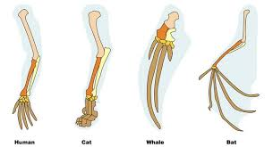](http://www.google.com/url?sa=i&rct=j&q=homologous+structures&source=images&cd=&cad=rja&uact=8&ved=0CAcQjRw&url=http://www.vce.bioninja.com.au/aos-4-change-over-time/evolution/evidence-for-evolution.html&ei=1fhMVdGrFoyegwSK5IDIDA&bvm=bv.92765956,d.eXY&psig=AFQjCNHkNR9PN_Hu0RlJCOxz5dlyazDoyw&ust=1431194177295452)

1. Charles Darwin developed his theory of Natural Selection based upon the presence of variations within a species. What is genetic variation within a species? Why are these variations important to the survival of the species?

**Life Science (Chapters 11, 12, & 14)**

1. Review your Venn Diagram comparing mitosis and meiosis. Why are both needed in organisms that use sexual reproduction?
2. Compare the cells produced from mitosis and meiosis. How are they different?
3. What are the differences between sexual and asexual reproduction?
4. How many chromosomes are found in human body cells? Sex cells?
5. What are some problems associated with cloning?
6. A bird is heterozygous for white body feathers. Is white a dominant or recessive trait? How do you know?
7. In order for a recessive trait to be expressed or shown in an organism _______ parent(s) must have 1 recessive allele.
8. If you cross a short strain of grass (gg) with a medium strain of grass (Gg), what is the probability of getting short strain grass as offspring of these two plants?
9. Determine the possible genotypes and phenotypes of a cross between a heterozygous brown rabbit and a homozygous brown rabbit. Use the letter B to represent the alleles.

1. What do the arrows indicate in a food chain or web? (see pg. 570, both diagrams)
2. Draw a simple food chain using the following organisms: hawk, grass, rabbit (make sure your arrows are drawn from the food source to the consumer)
3. What are symbiotic relationships?
4. Describe 3 types of symbiotic relationships. (see examples on pg. 563)
5. Burmese Pythons have been released into the Everglades by pet owners that no longer can handle the large snakes. What are these types of non-native animals called? How does this affect the ecosystem?
6. See the energy pyramid on pg. 571. What happens to the amount of available energy the higher the level on the pyramid?
7. Using the same diagram, what would happen to the population of grasshoppers if the birds became extinct?